The Battle between the Branches: Positive and Normative Theories of Judicial Review
Michael Beenstock
Hebrew University of Jerusalem
September 14, 2023
The following explains verbally and visually the basic theoretical results obtained formally in my paper with same title.

Abstract
My paper is related to the debate in legal philosophy between the legal positivists (and Dworkin), who are in favor of judicial review and the political constitutionalists, who are against it. I use formal methods from game theory and statistical theory to study the tension between the legislature and the judiciary, when the latter is empowered with judicial review. In the positive theory the legislature and the judiciary are adversarial; the judiciary may be more or less activist, and the legislature may engage in override, politicize appointments to the judiciary, or simply ignore rulings of the supreme court. The positive theory predicts that the outcome of the battle between the branches is Pareto inefficient in terms of infringement of the constitution and the public benefit from legislation.
Under the normative theory the legislature and the judiciary cooperate. As expected, the outcome is Pareto superior. The normative theory provides a structural basis for enhancing the efficiency of judicial review. It also sets a benchmark for comparing efficiency under political constitutionalism with the best possible outcome under judicial review.
Whereas the positive theory characterizes the world as it is. The normative theory refers to an ideal world. In a follow-up paper I plan to study efficiency under political constitutionalism and to compare it with efficiency according to the positive and normative theories of judicial review.
By using formal methods and clearly stated axioms, such as rationality, the robustness of these comparisons is transparent axiomatically and methodologically. Legal philosophers who disagree should be able to pin-point the source of their disagreement.

Introduction
I treat Supreme Court justices as regulators who have powers of judicial review over the Legislature and the Executive as the regulated. Since judicial review is not an exact science, the justices have discretion in their judgments; they may be more or less 'activist'. Indeed, I generalize by assuming that they may not necessarily behave like Dworkin's Hercules. The regulator has power over the regulated, but so do the regulated have power over the regulator. The Government may mitigate the power of the judiciary by legislating override and through the politicization of appointments to the Supreme Court. I use game theory to study the mutual tension between the judicial and legislative branches. The tension between the judiciary and the Executive are similar in principle, but different in practice, and are not considered here.
There is a distinguished tradition in political science to study issues of polity using game theory. Indeed, Condorcet invented game theory in the 18th century to study coalition politics, political scientists used it to study the politics of nuclear armament and disarmament (Freedman 1997), and, closer to home, Vanberg (2004) used it to study how the Bundestag ignores strike-down rulings of the Federal Constitutional Court.
The 'regulator game' serves as the axiomatic basis for the positive theory of judicial review. It is positive because it intends to provide a theory of how legislators, who might be voted-out in the next elections, behave when they are regulated by unelected regulators, who apart from protecting the constitution may also enjoy authority. I derive the equilibrium of the regulator game in which neither branch wishes to alter its behavior. This equilibrium turns out to be antisocial in the sense that potentially beneficial legislation is suppressed, the legislature wastes political energy on battling with the judiciary, and the judiciary wastes political energy on battling with the legislature. On the other hand, infringements of the constitution are reduced, but not eliminated.
This positive theory of judicial review is only indirectly related to existential criticism of judicial review by political constitutionalists, such as Waldron (1999) and Bellamy (2007), who oppose judicial review in principle. The positive theory encompasses a special case in which judges behave as Dworkin's Hercules. However, even in this special case the equilibrium outcome turns out to be antisocial. The revocation of judicial review is a game-changer, which requires a separate analysis from the present one.
Whereas the positive theory is concerned with the world as it is, the normative theory is concerned with the world as it might be if the players in the regulator game cooperated with each other instead of battling-out, and sought to achieve the best social outcome instead of the antisocial outcome under the positive theory. An important axiom of the normative theory is that there is trade-off between infringement of the constitution and the social benefit from legislation. Each law renders benefit to the public, but it might also infringe the constitution. In the positive theory the judiciary cares mainly about defending the constitution; it attaches little if any value to the public interest. The legislature cares mainly about the public interest; it attaches little if any direct importance to defending the constitution. It attaches indirect importance because legislation, which runs the risk of strike-down, is unlikely to be tabled in the first place. Whereas there is little or no trade-off under the positive theory, matters are different under the normative theory.
Whereas the positive theory is based on game theory, the normative theory is based on the truncated bivariate normal distribution in which the constitutional infringements (if any) of legislation may be correlated with the public benefit from legislation. In the normative theory infringements of the constitution are 'capped' from above; laws that have infringements greater than x are struck-down. If the correlation is positive, the public value if legislation is capped from above; laws with public benefit greater than y are not proposed by the legislature. A social welfare function is proposed, which penalizes infringements but attaches positive value to the public benefit of legislation. The optimal social values of x and y maximize the social welfare function.
Positive Theory
Each law generates public benefit (b), induces constitutional infringement (t) and may be struck-down with probability p, where t and p may be zero. The probability of strike-down is assumed to vary directly with t (laws with greater infringement are more likely to be struck-down). This probability varies directly with activism (a) by the judiciary, which serves as its main policy instrument. The legislature/government has instruments too, such as override clauses and politicization of appointments to the supreme court (z), which reduce the probability of strike-down. The probability of strike-down also varies directly with features of the constitution (c), such as entrenchment, scope and prolixity, which are assumed to be exogeneous (c does not depend directly on a and z).
The legislature is assumed to set its legislative agenda for its term in office with the objective of maximizing its political surplus defined as the expected value of the public benefit generated by the agenda as a whole minus the political cost of setting its instruments (z). The contribution to the former to each item of legislation is (1-p)b (its public benefit multiplied by the probability of not being struck-down). The cost of the latter varies directly with z. The benefit to z is that it reduces the probability of strike-down for the agenda as a whole.
The judiciary seeks to minimize infringement of the constitution by the agenda as a whole minus the political cost of activism. The political cost to activism varies directly with a; supreme court justices prefer less activism to more. The judiciary sets its policy of activism for the duration of the term in office.
The political benefits from items of legislation and their infringements vary, and are assumed to be distributed bivariate normal, i.e. political benefits and infringements are normally distributed, but may be correlated.
Finally, legislators and supreme court justices are fully rational. Legislators know how justices will respond to z (e.g. override) by stepping up their activism, and justices know how legislators will respond to their activism by stepping up z. Hence, legislators internalize the behavior of the judiciary, and the judiciary internalizes the behavior of the legislature. I obtain the equilibrium of the regulator game, which is implied. In this equilibrium z and a are determined, such that neither side wishes to deviate from this equilibrium. I also determine the conditions under which such an equilibrium exists, If it doesn't exist, the battle between the branches is explosive.
In the equilibrium legislators suppress legislation; bills are not presented to the legislature because they expect that they will be struck-down. As a result, supreme court justices do not have to strike-down legislation because legislators have practiced self-restraint. On the other hand, in the equilibrium the constitution is infringed, but it is not in the interest of the judiciary to strike-down the offending legislation. So, supreme court justices practice self-restraint too. Matters would be different if there was no cost to activism by the supreme court.
An important analytical concept is the 'marginal item of legislation', which is the law that is just about worthwhile for the legislature to risk legislating given that it might be struck-down. The marginal item benefits the public but it infringes the constitution sufficiently to increase the risk of being struck-down. Sub-marginal items of legislation are suppressed by the legislature. However, through override (z) the legislature can turn sub-marginal legislation into super-marginal legislation at a cost. In equilibrium the legislature has no incentive to pay this cost. Nor does the judiciary have an interest in paying the cost of increased activism. In equilibrium the marginal item of legislation infringes the constitution by t*, its probability of being struck-down is p* (which increases with t*) and it generates a public benefit of b*. The payoff to the legislature is (1 – p*)b* minus the fixed cost of z*, which equals zero in equilibrium. The (negative) payoff to the judiciary is t* minus the fixed cost of activism (a*), which also equals zero in equilibrium. I solve for t* etc.
Two types of equilibria are analyzed. In the first, supreme court justices are Herculean (in the sense of Dworkin); they are entirely dispassionate, they are not influenced by their beliefs and values, they get no satisfaction from their power, their rulings are free of all arbitrariness. In the second, justices are just as human as anyone else; they enjoy the authority invested in them; their rulings are not free of all arbitrariness. In the first case judges become justifiably more activist if the legislature attempts to limit their authority (by increasing z). Herculean judges may serve as perfect agents in protecting the constitution, but they have no particular expertise in judging the public benefit from legislation. They will strike-down laws for which the public benefit is greater than their constitutional cost. Hence, the Herculean equilibrium does not generally serve the public interest. Matters are obviously worse under the 'human' equilibrium because laws are struck-down on arbitrary grounds.
In a deterministic world the equilibrium should emerge spontaneously and instantaneously. In practice the regulator game may be out of equilibrium because the players have imperfect information about each other. In this case the legislature tables legislation, which the supreme court strikes down. However, the positive theory predicts that both sides learn from their mutual mistakes, and eventually the regulator game converges to its equilibrium.
In summary, the positive theory predicts that the instruments (z and a) are positively correlated, and that they both vary directly with entrenchment etc (c), These and related predictions are currently under empirical investigation using cross-section data by country from The Comparative Constitutions Project. The positive theory implies that the number of laws struck-down under-estimates the power of judicial review over the legislature.
Normative Theory
Outcomes under the positive theory are generally not in the public interest for two reasons. First the political energy wasted by both sides in the regulator game is a dead-weight cost to the public. Second, and more important, the legislature represses legislation that would have been in the public interest. The objective of the normative theory is to define the circumstances under which judicial revue serves the public interest to the greatest possible degree. Unlike the positive theory, which is concerned with the world as it is, the normative theory is concerned with the world as it should be. In this ideal world the legislature and the judiciary cooperate instead of battling-out. The judiciary has a comparative advantage over the legislature in evaluating infringements of the constitution (t), and the legislature has a comparative over the judiciary in evaluating legislation (b). The latter stems from the fact that in democracies legislators are sensitive to the implications of their actions in the next election. The former obviously stems from the fact that judges have an expertise in constitutional law.
A crucial feature of the normative theory is that there is a trade-off between infringements of the constitution and their public benefit. Let B denote the public benefit from the legislative agenda (B is the sum of b) and T denote its constitutional infringement (T is the sum of t). Let W = f(B,T) denote the public interest, which varies directly with B and inversely with T. Even if there is no agreement on how to weight B and T, W obviously increases if B increases and T decreases. It also increases if B increases given T and if T decreases given B. Such Pareto improvements arise because the incumbent values of B and T are 'inefficient'. If both B and T increase what happens to W depends on how to weight B and T. Even here there are some guide-lines. If B and T are large, a marginal increase in B is likely to increase W by less than a marginal increase in T decreases W because the marginal price of B varies inversely with B, and the marginal price of T increases with T.
Matters ae greatly simplified if there is agreement on how to weight B and T. I assume, for illustrative purposes, that the 'elasticity of substitution' between B and 1/T is one, which means that the public interest remains unchanged when B increases by a percent and 1/T decreases by a percent.
Whereas game theory serves as the axiomatic foundation of the positive theory, the doubly truncated bivariate normal distribution serves as the statistical foundation of the normative theory. A distribution is 'truncated' when values are capped from above or below. For example, suppose incomes range between 0 and 100 and mean income is 55. If people with incomes over 90 are capped (they are omitted from the data) the truncated mean must be less than 55. If people with incomes less than 10 are capped, the truncated mean must be greater than 55. In the former case truncation is from above (or from the right) and in the latter truncation is from below (or from the left). If infringement (t) is truncated from the right, T must decrease. If legislation (b) is truncated from the right B must increase. When b and t happen to be correlated the doubly truncated bivariate normal distribution is needed to calculate the truncated values and B and T.
To convey the nature of the normative theory it is assumed for expositional simplicity that the optimization is carried out with respect to t alone, i.e. laws with infringements larger than some upper limit are struck-down, i.e. t is right-truncated. Figure 1 is drawn under the assumption that infringements and public benefit are positively correlated. Schedule QQ' represents the 'transformation frontier' between the truncated values of B and T; it plots all the feasible combinations of B and T for different degrees of right-truncation. At Q right-truncation is complete; all laws involving infringement are struck-down. At Q' there is no truncation; no laws are struck-down. Hence, truncation increases along schedule QQ' from right to left. In general, QQ' is an 'open hull' as drawn; it has a positive slope in the middle (between u and v) but inflects after the beginning (at u) and towards the end (at v).
The social welfare function is represented by iso-welfare curves such as W₀, which plots all the combinations of B and T that have the same public interest. They slope upwards because legislation has a public benefit while infringements of the constitution are against the public interest. Social welfare above W₀ is larger and is smaller below it. The public interest is maximized at q at which the socially optimal value of cap to infringement is determined.
Figure 1 Solution to the Normative Theory of Judicial Review
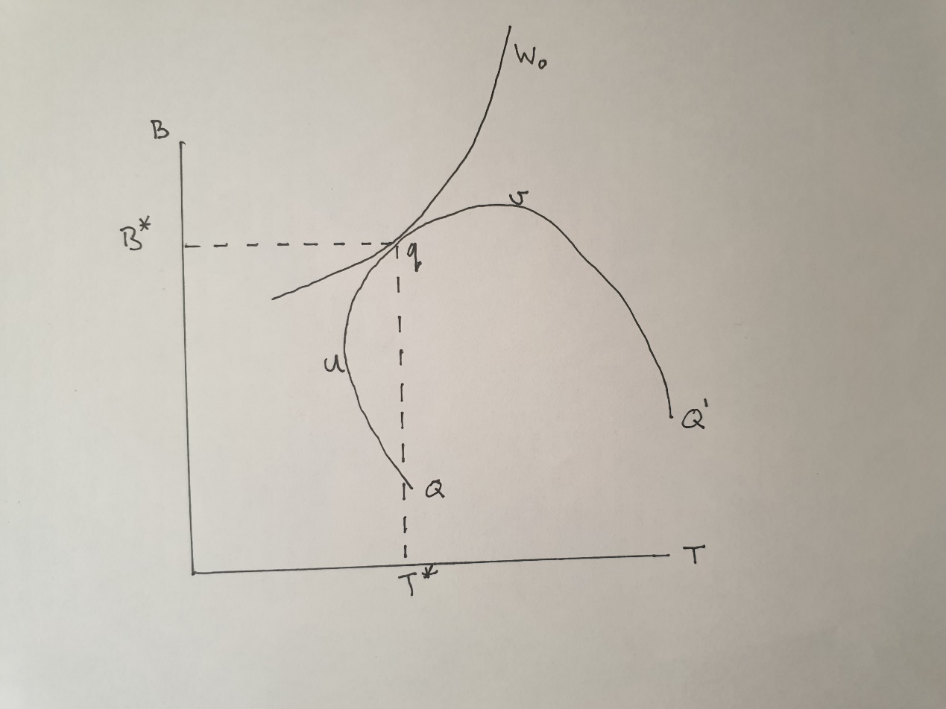
The inflexion point at v would be the solution if no weight was attached to defending the constitution and all that mattered was the public interest. Note that at v infringement is capped. If at the other extreme all that mattered was protecting the constitution, the solution would be at u. Obviously infringement is more capped at u than at v. Note that segments Qu and Q'v are redundant because they slope upwards from right to left. Only segment uqv is relevant because it slopes upwards from left to right. Along this segment the trade-off between the public benefit of legislation and infringement positive; more public benefit (B) can only be achieved at the expense of more infringement (T).
There are two types of inefficiency. First, 'judicial inefficiency' arises when B and T lie inside the transformation frontier QQ’. In this case infringement of the constitution could have been reduced given the public benefit from legislation, and/or the public benefit from legislation could have been increased without further infringement of the constitution. Judicial inefficiency induces an avoidable loss in social welfare. Second, 'allocative inefficiency' arises when B and T lie on the transformation frontier but the location induces a loss of social welfare. The Pareto optimum is at q where the schedule W₀ is tangential to schedule QQ'. Therefore, allocative inefficiency arises at solutions between u and q and v and q.
In Figure 1 only infringement is capped. Since it was assumed that b and t are positively correlated, capping b should reduce infringement too. Obviously capping b directly reduces the public benefit of legislation. Figure 2 illustrates the normative theory when both b and t are capped. Superior outcomes for the public interest (W) should be obtainable when both b and t are capped. This exercise is carried out in Figure 2 under the assumption that B and T are equally weighted and that the correlation between b and t is a half. In Figure 2 the public interest (W) is measured on the vertical, the cap for t is measured on the y-axis (to the left) and the cap for b is measured on the x-axis (to the right). When y and x are zero the cap is 50 percent, i.e. 50 percent of legislation is struck-down and 50 percent of legislation is suppressed. When y and x equal 4 neither t and b are capped. When y and x equal -4 t and b are completely capped.
The hyper-surface (in color) is the three-dimensional counterpart to the two-dimensional schedule QQ' in Figure 1. The optimal caps are determined by the x and y coordinates that generate the largest public benefit (where the hypersurface is reddest). The hypersurface plateaus-out with respect to y but not with respect to x. This means that capping infringement reduces welfare given the cap on public benefit while capping public benefit given the cap on infringement has an ambiguous effect on welfare. Capping b given the cap on t initially is welfare improving but subsequently welfare decreasing. In Figure 2 welfare is maximized when y = 4 and x = -0.2. Hence, the judiciary hardly strikes-down legislation but the legislature engages in self-restraint by truncating as much as 58 percent of its legislation.
Figure 2 The Optimal Caps for Infringement and Public Benefit
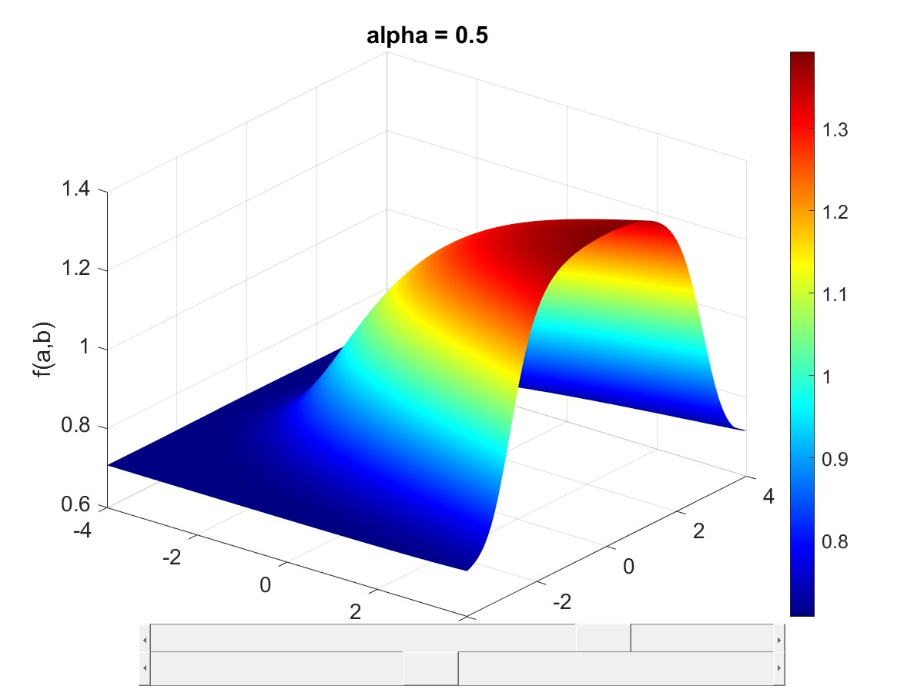
Judicial inefficiency arises when the coordinates for y and x lie inside the cavity subtended by the hypersurface in Figure 2. Allocative inefficiency arises when the location on the hypersurface is not at its peak e.g. when it is yellow.
Figure 3 Twin-Peaked Hypersurface
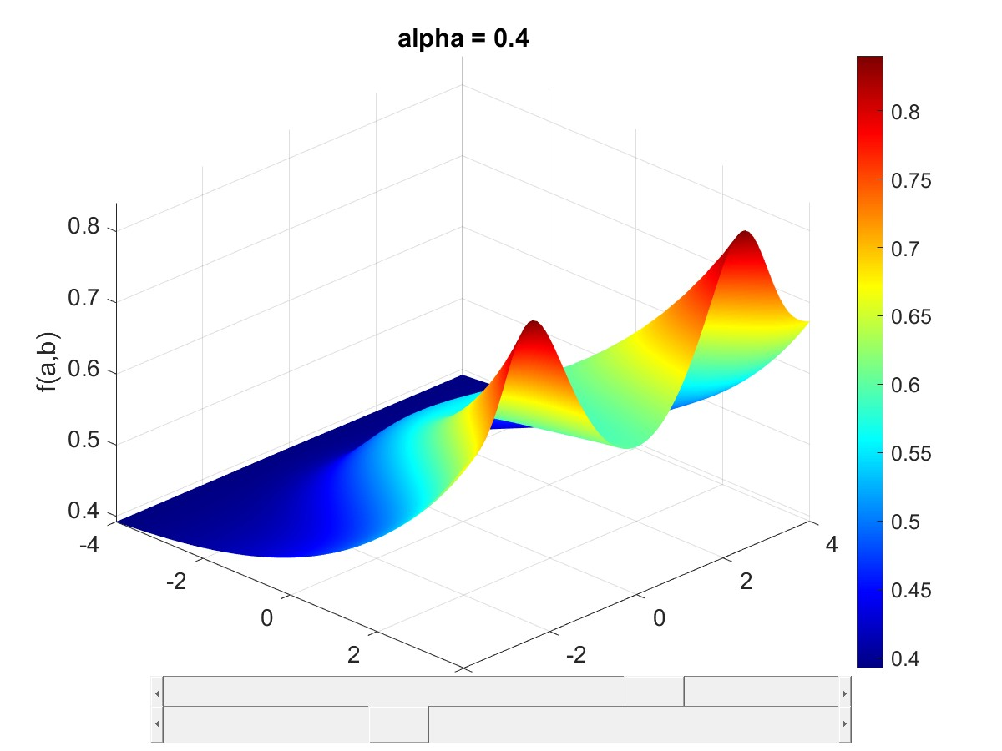
The hypersurface is quite sensitive to the correlation between b and t and to their relative weights on the welfare function. Figure 3 illustrated the implication for Figure 2 when the relative weight is raised from 50:50 to 40:60.
Caveat
I have assumed that the heterogeneity in the how laws infringe the constitution and benefit the public may be parametrized by the normal distribution because its mathematical properties have been widely studied. Different parametric assumptions may generate different conclusions for the positive and normative theories of judicial review that have been proposed. This is just the beginning.

